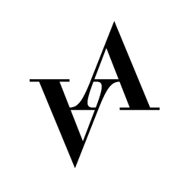

**Application to Orchestra 2024**

**Vadstena-Akademien**

**Production:** Fotografen. World premiere.

**Place:** Vadstena Gamla Teater / Old Theatre, Vadstena

Please fill out this form and send it together with a CV, cover letter, a YouTube link with your playing and 2 relevant references to [apply@vadstena-akademien.org](mailto:apply@vadstena-akademien.org) no later than 18 February, 2024.

**Name**:

**Address**:

**Postal number**:

**City**:

**Country**:

**Email**:

**Phone**:

**Birth year**:

**Instrument:**

**Relevant education**:

**School**:

**Length of education**:

**Relevant projects within the area**:

**Previous experience**:

**References with contact information**:

**Are you also applying for the Baroque Academy 2024?**

YES

NO